# COSSA Regional Technology and Education Center (CRTEC)

# LIVE WORK MANUAL

Rev. 9-21-20

# C:\Program Files\Microsoft Office\MEDIA\CAGCAT10\j0278882.wmf

# COSSA does not discriminate or deny services on the basis of age, race, religion, color, national origin, gender, and/or disability. Appropriate consideration shall be given to veterans with applicable state and federal laws and regulations.

**COSSA Regional Technology and Education Center (CRTEC)**

# LIVE WORK MANUAL

USE OF CRTEC FACILITIES AND STUDENT LABOR

CRTEC shops and laboratories are publically owned and may only be used for the instruction of secondary students, or adult students enrolled in short-term training. Projects that reinforce the program of study and vehicles or projects needing repair align with the curriculum and support the “hands-on” learning of students enrolled in CRTEC programs. These projects and vehicles come from individuals outside of the Agency, and are collectively called “live work” – as they emulate the real-world conditions the student will encounter in their industry.

CRTEC cannot “lose” money on educational projects. The cost of project materials and parts must be covered by the owner of the vehicle or project. Repair parts will be ordered by the student/instructor in charge of the project, but must be paid for by the owner of the vehicle/project. For some student work, the repair parts may be charged to the student organization accounts, but the cost of all materials and repair parts must be recouped and the student organization account repaid.

Students and instructors will not be paid for the labor they put into a project if that project is part of their program of study. However, the owner of the project may give a cash donation to the student organization associated with the program of study. This money is “student” money, to be used for the benefit of the students, and may not be co-mingled with public funds. Instructors and students are not allowed to accept payments or donations – all money must be handled by the CRTEC business office.

LEGAL BACKGROUND

Idaho Code 18-1359 prohibits the use of public funds or property to obtain a personal benefit. In addition, a public employee cannot personally gain from any contract issued as part of the CRTEC teaching mission. Violations of this statute can result in up to a $1000 fine, one year in jail, and loss of teaching certificate.

CRTEC’s insurance carrier requires that personally and publically owned equipment and tools not be mixed in the CRTEC shops. Instructors must remember that publically owned equipment and tools may be used at any time by any authorized user. Personally owned equipment and/or tools are not covered under the Agency’s liability or comprehensive insurance. All equipment and tools, no matter who owns them, are subject to inspection and search at any time.

Vehicles in the shop must benefit the students’ program of study. Vehicles may not be “stored” for long periods of time unless they are owned by COSSA. Personal vehicles may not be stored in the shop unless these vehicles have been accepted into the live work program using the forms attached to this policy.

Student or patron vehicles may be worked on during times designated by the instructors as “project” time, and then they must be removed. Any student or patron vehicles kept longer than one class period must have been accepted into the live work program using the forms attached to this policy. When the student graduates from the program of study their vehicles must be removed. No student work on vehicles or projects may occur when school is not in session (i.e., during breaks, teacher only workdays, or over the summer). Some exception to this policy may be made when student organization “teams” practice for state or national contests in the evenings, on weekends, or during the summer.

APPLICATION OF THE LEGAL REQUIREMENTS

CRTEC shops may not be used for any purpose other than instructing students and fulfilling the program of study for which they were designed. Projects and activities related to the Career-Technical Student Organizations (CTSOs) associated with each program of study are allowed, as CTSOs are an integral part of any program of study. Instructors and students may not work on vehicles or projects kept in the shop for more than one day unless they have been accepted into the live work program using the forms attached to this policy. Vehicle or project work completed within one class period is exempt from this policy.

Any vehicle or project work that requires payment of fees or for parts must be signed into the live work program regardless of how long the vehicle repair or project takes, even if it is only one class period. To ensure separation of the authority to issue the contract for live work and collection of any money generated by the live work, instructors may not receive payments for services rendered. Payments must be made through the business office.

VEHICLES IN THE SHOP

Based on Idaho Code and CRTEC’s insurance coverage, there should never be any vehicle in the shop not owned by COSSA, unless it is directly related to the program of study and has been accepted into the live work program using the forms attached to this policy. Short-duration (one class period) work is an exception, as long as the work does not require payment of fees or for parts.

SEGREGATION OF DUTIES

Instructors may not receive payments for services rendered. Instructors may not enter into contracts. Therefore, all individuals dropping off their vehicles or projects for work must check-in through the business office and sign the appropriate paperwork, and then check-out through the business office in order to pay for the services rendered.

REQUIRED FORMS

Front office staff will use the permission for vehicle work, release of liability, repair order, and repair order invoice (attached) to check-in/check-out vehicles and/or projects and to track vehicles and/or projects accepted into the live work system.

Instructors will generate estimates, parts order details, and report of work accomplished through the on-line sites of Mitchell on Demand and NAPA PRO Link.

Instructors will make electronic copies of all related paperwork, especially permission for vehicle work, release of liability, and repair order, so that a permanent record of work performed can be retained.

LIVE WORK TEST DRIVES

A part of teaching students on live work vehicles involves taking the vehicle on a “test drive” – either before the work begins, to help diagnose the problem; or after the work is complete to verify that work has fixed the problem. The customer must sign a release of liability that authorizes the instructor and/or students to test drive the vehicle. Other test driving rules are:

1. The student assigned to repair the vehicle will normally be the test driver so that the student can learn how the problem is being exhibited in drivability, performance, etc. The instructor will ride along for every test drive.

2. Students should not normally drive beyond the CRTEC campus, although a problem that only presents itself at highway speeds may require an exception to this rule.

3. It is always best to have two students and the instructor in the vehicle to prevent a student from being alone with the instructor. This is especially true if the student and teacher are of opposite gender. If the size of the vehicle prevents three persons from riding, an exception to this rule may be required.

4. Under no circumstances should the student drive the vehicle alone.

In some rare cases the customer’s vehicle requires an extended test drive, through several drive cycles, to know if the repair is complete. The instructor will make separate arrangements with the customer to drive the vehicle for extended times and miles if this is the case.

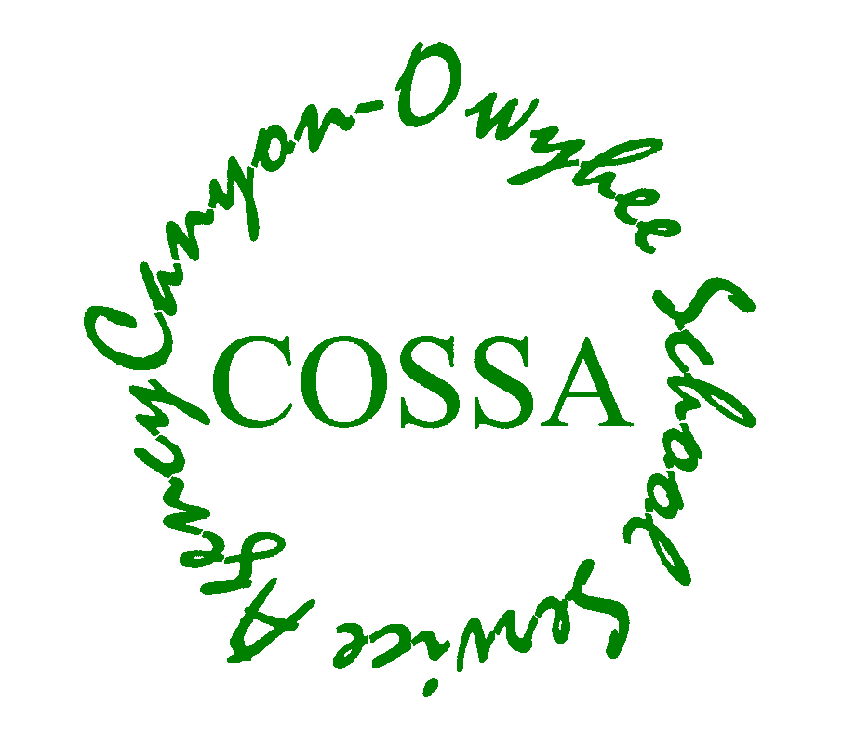

**PERMISSION FOR VEHICLE WORK**

**(Original Copy Submitted to Business Office)**

I give permission for to work on the following vehicle.

Program Name (Please Print)

Vehicle Year, Make & Model:

VIN: _________________________________________________________

**Please submit PROOF OF INSURANCE or HOME STORAGE INSURANCE and VEHICLE REGISTRATION.**

I give my permission for the following anticipated repairs or work:

* Students are responsible for communicating costs to the vehicle or project owner through written estimates. Owners will purchase requested parts and deliver said parts to the student/instructor responsible for the work.
* Vehicle or project owners are welcome to inquire about the account balance at any time (208.482.6074).
* I understand that all costs associated with this vehicle are to **be paid in full before the vehicle or project can leave the campus**.

**Name of Registered Vehicle Owner Signature Date**

**(Please Print)**



**Release of Liability**

Before CRTEC students or personnel work on your vehicle/project, it is our policy that you read and sign the following agreement:

This agreement entered into between the CRTEC’s CTE programs (Automotive Technology, Pre-Engineering, Building Trades, Diesel Technology and/or Welding programs) and the owner of the attached described vehicle and/or equipment is for the express purpose of offering the vehicle and/or equipment to the students of this program for **educational training only**. Consequently, the program **cannot offer a guarantee of proficiency or quality of work** done on the attached described vehicle or equipment.

Initial ______

Date _______

I hereby authorize repair work on my vehicle or project. Unless otherwise noted, the purchase of repair parts and materials for completion of work is my responsibility. Furthermore, I authorize students and employees to operate the described vehicle or equipment for the purpose of testing and inspection, including test drives by the student and/or instructor. An expressed mechanic’s lien is acknowledged on the vehicle or equipment to secure payment. CRTEC will not be held responsible in case of fire, theft, accident or any other cause of damage to the vehicle or equipment. CRTEC will not be held responsible if their work on the vehicle causes the spread of the Coronavirus or other infectious disease. I understand that routine after-maintenance cleaning will be conducted on my vehicle, but not “disinfecting” that could kill the Coronavirus or other disease.

My signature hereunder constitutes acceptance of the proposal.

SIGNATURE DATE

**COSSA Regional Technology and Education Center**

**Repair Order (RO) Information**

**(Please Print)**

Date ______

R.O. Invoice # _____________

Instructor ______

Class Period ______

Name: Vehicle VIN: _______________________

**Present Registration Form**

(No Exceptions)

Address: **\*** Insurance Carrier ____

(Street Address)

Year

(City, State, Zip) Make

Model

Phone (Home/Cell): License #

Phone (Office): Automatic or Manual Transmission

Description of Work Needed:

**Note: One R.O. fee due per vehicle or project. This fee covers shop supplies and hazmat handling/removal (hazmat is applicable to Auto and Diesel only). Instructor may waive all or part of these fees if appropriate:**

Auto Tech** $10.00(sup) $5.00(haz) ______

Pre-Engineering $10.00 ______

Building Trades $15.00 ______

Diesel Tech** $10.00(sup) $5.00(haz) ______

Welding $15.00

**\*Vehicle Insurance Requirement**

The COSSA Regional Technology and Education Center (CRTEC) does not have Liability or Comprehensive insurance to cover any type of accident your vehicle might be involved in while being worked on in our shops. Therefore, it is a mandatory requirement that all vehicles on our campus are covered with a **Liability Policy** through your insurance carrier. **This includes vehicles that are not in working condition for any reason.** In addition, if you would like protection against fire/theft or vandalism, please ask for a **Comprehensive** **Policy** from your insurance carrier as well.

** Fees generated using the “Mitchell on Demand” invoicing system automatically increase depending on the amount of parts and/or labor in the job. Fees shown are “starting” fees.

|  |  |  |  |  |  |
| --- | --- | --- | --- | --- | --- |
| 109 Penny Lane  Wilder, ID 83676  Phone 208-482-6074  Fax 208-482-7904  **Canyon-Owyhee School Service Agency**  R.O. INVOICE   |  | | --- | |  | | | | |  |  |
|  |  |
|  |  |
|  |  |
|  |  |
|  |  |  |  |  |
|  |  | **DATE: _________** |  |  |
|  |  |  |  |  |
|  |  | **R.O. INVOICE #** |  |  |
| **Bill To:** | **For:** | **PROGRAM:** |  |  |
|  |  |  |  |  |
|  |  |  |  |  |
|  |  |  |  |  |
|  |  |  |  |  |
|  |  |  |  |  |
|  |  |  |  |  |
| **DESCRIPTION** | | **AMOUNT** |  |  |
|  | |  |  |  |
|  | |  |  |  |
|  | |  |  |  |
|  | |  |  |  |
|  | |  |  |  |
|  | |  |  |  |
|  | |  |  |  |
|  | |  |  |  |
|  | |  |  |  |
|  | |  |  |  |
|  | |  |  |  |
|  | |  |  |  |
|  | **TOTAL** | $0.00 |  |  |
| Make all checks payable to COSSA | |  |  |  |
| If you have any questions concerning this invoice, contact Dawnita Tincher at 208-482-6074. | | |  |  |
|  |  |  |  |  |
| **THANK YOU!**   |  | | --- | |  | |  |  |  |  |
|  |  |  |  |  |
| Canyon-Owyhee School Service Agency (COSSA) is a public school cooperative serving the special education, career-technical, and alternative education needs of students from  Homedale, Marsing, Notus, Parma, and Wilder School Districts.     |  | | --- | |  | |  |  |  |  |
|  |  |  |  |  |
|  |  |  |  |  |